Please follow these steps to import your class roster into Turning Point Cloud –

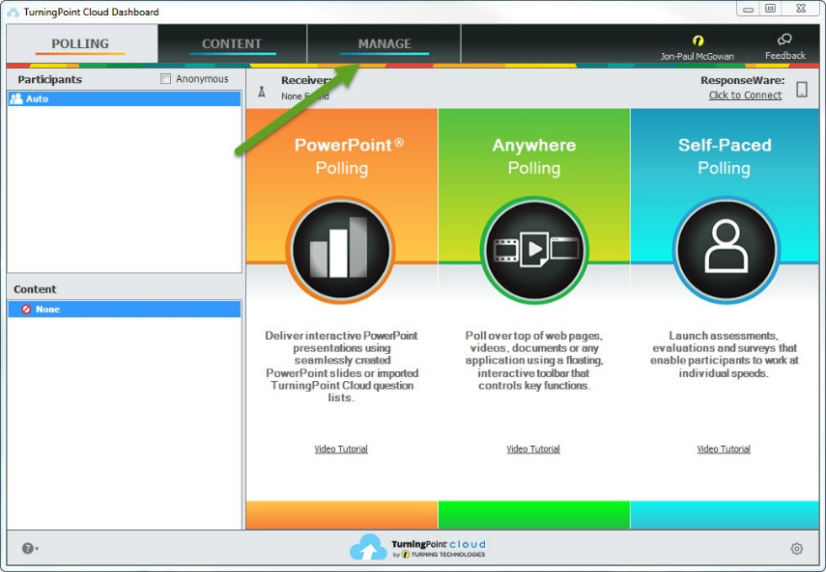
- From your main screen click on Manage.
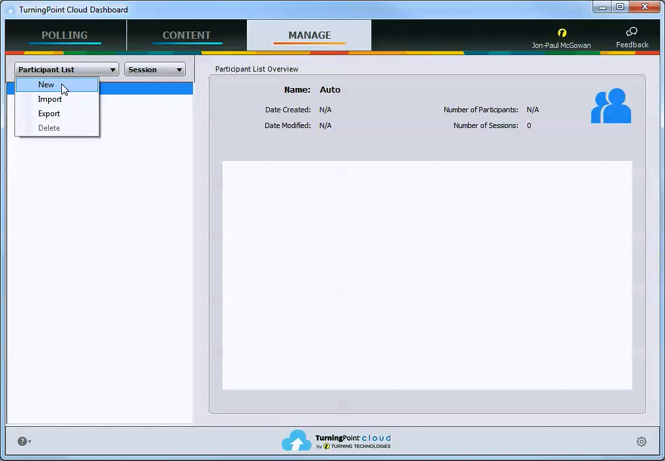
- From the Manage Tab Click on Participant List then New.
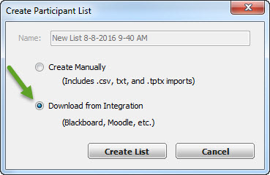
- Click on Download from Integration
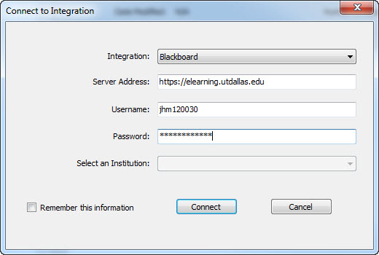
- Enter the information requested.
  - Integration: Blackboard
  - Server address: https://elearning.utdallas.edu
  - Username: Your NetID
  - Password: Your UTD Systems Log-In Password
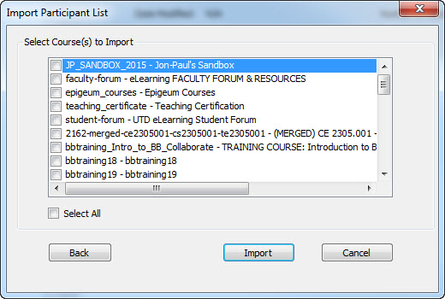
- Select the course, or courses, whose roster you wish to import.
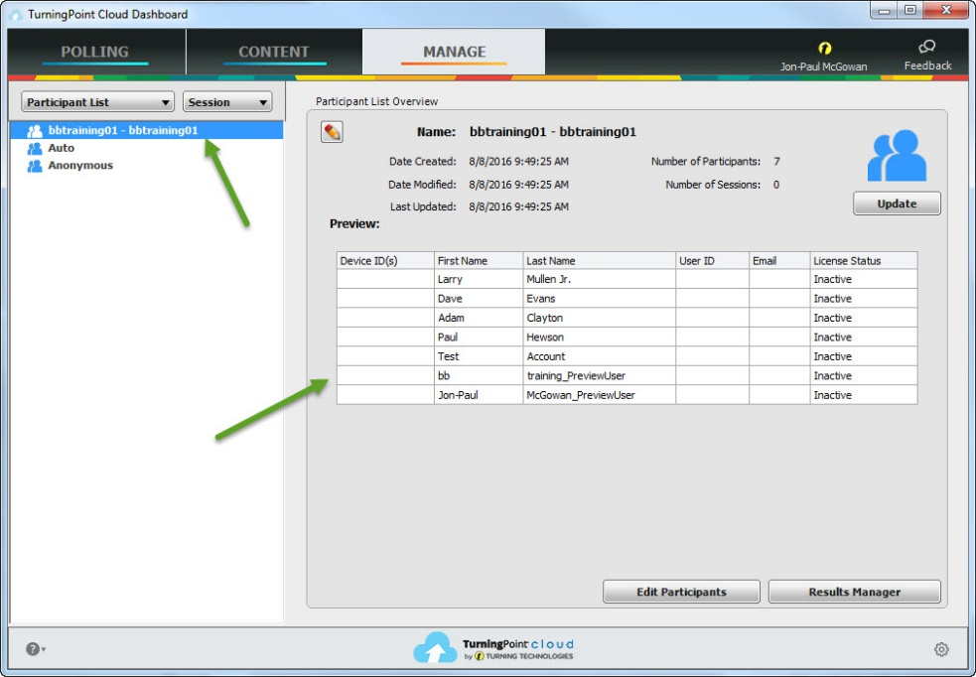
- Your courses will be listed on the upper right and the roster will be located in the main display area.
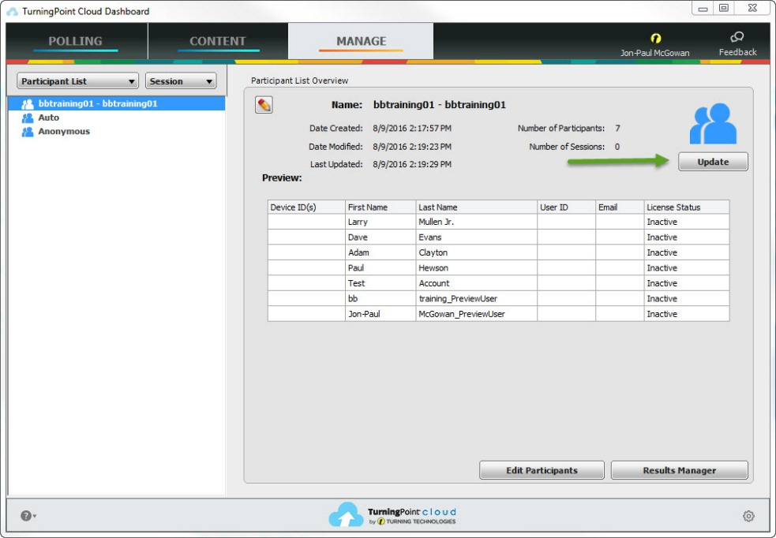
- To update your roster click on the Update button and provide the same information as Step 4. You will then receive a confirmation stating whether or not users were updated.
UTD eLearning Contacts:
- Jon-Paul McGowan, Trainer, jpmcgowan@utdallas.edu, 972-883-4842
- Roopa Chandrasekhar, Training Manager, Roopa.Chandrasekhar@utdallas.edu, 972-883-2783

