Dear Student,

Welcome to Turning Point Polling.
Below are instructions to assist you with the student registration process.

Before you begin:
- You must be unconditionally admitted as a student at UT Dallas.
- You must be enrolled in an academic course that uses Turning Point Polling.
- You must purchase a Turning License.
- Depending on the instructor’s policy, you may need to obtain a Turning Technologies RFLCD Clicker as well.
Once you have these, please follow the below instructions to get set up.

- Log into ELEARNING (https://elearning.utdallas.edu).
- On the ELEARNING HOMEPAGE, locate the COURSE WHICH USES TURNING POINT POLLING.
- Click on the course title, to enter the course. (For example, in this case the course is called “bbtraining07”).
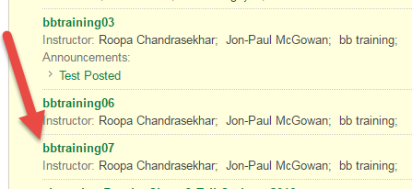
- In the course, on the LEFT HAND SIDE MENU, you should see a link called TURNING ACCOUNT REGISTRATION (or TURNING TECHNOLOGIES REGISTRATION). Click on that link.
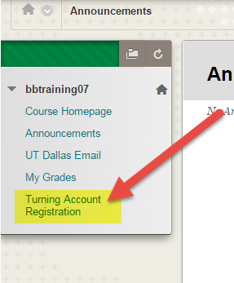
- You will be taken to a TURNING ACCOUNT CREATION window. In the space provided, ENTER YOUR UTD EMAIL ID, and click on CREATE AN ACCOUNT.
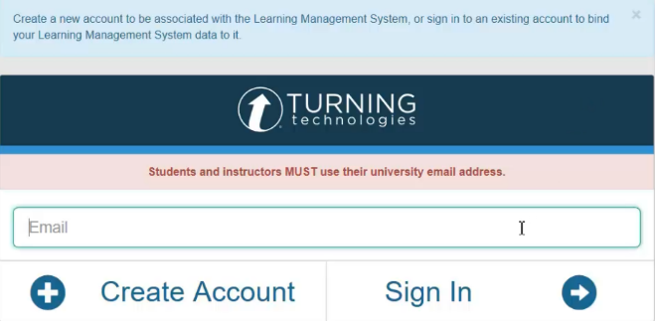
- You will see a message on the screen, which states that a verification email has been sent to your UTD email.
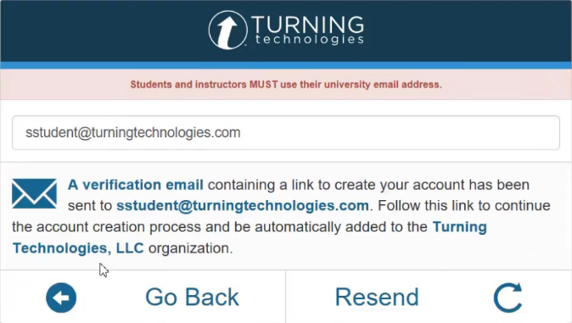
- Open your UTD Email, find the verification email, and click on the link within the email to continue the account creation process.
- You will be taken to an ACCOUNT CREATION SCREEN.
Enter in the required user information.
  - Enter your FIRST NAME and LAST NAME.
  - Select STUDENT, from the role drop down menu.
  - Enter a UNIQUE PASSWORD.
  - Accept the TERMS OF USE.
  - Click FINISH.
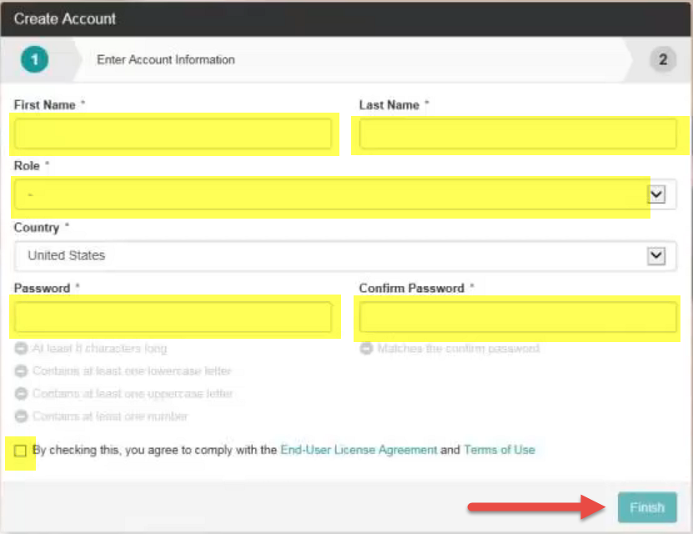

- Next you will be asked to activate your account.
Enter the following information:
  - LICENSE CODE: Enter the Turning License Code.
  - RESPONSE DEVICE ID: If you have an RFLCD device (clicker), enter the device id. It is a 6 digit alphanumeric code found on the back of the device.
  - CLICK FINISH.
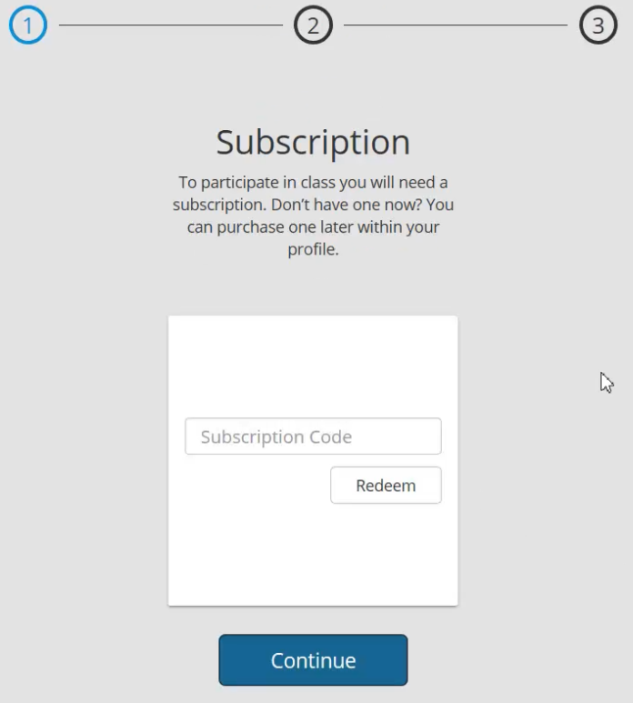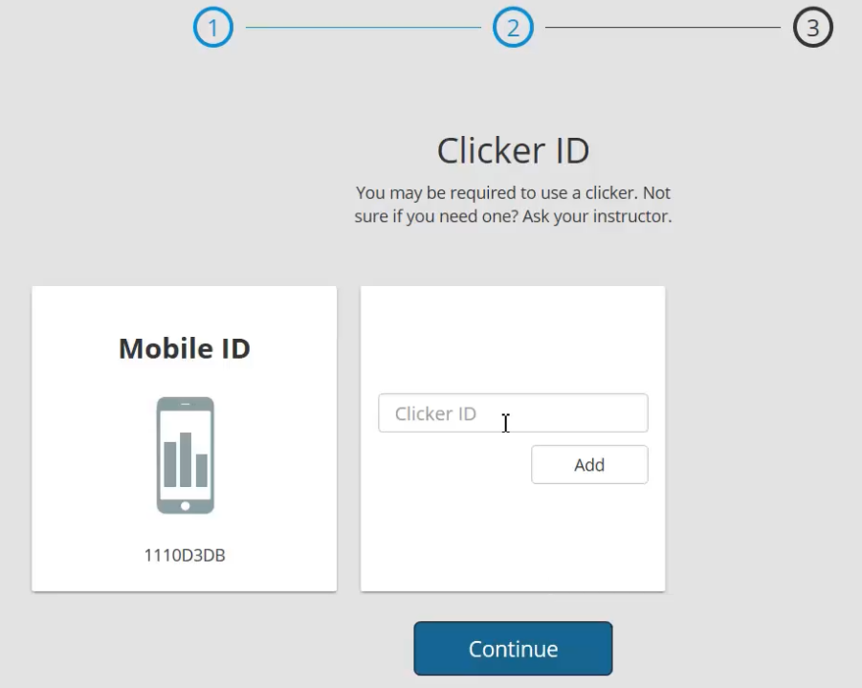
Note: If you want to do Step # 9 later, click FINISH. Your account will be created. But it will not be active. To activate your account, you will need to follow the below steps:
- Log into ELEARNING (https://elearning.utdallas.edu) > go into the COURSE > look on the LEFT HAND SIDE MENU > click on the TURNING ACCOUNT REGISTRATION LINK.
- On the next screen, enter your UTD email id, and click SIGN IN.
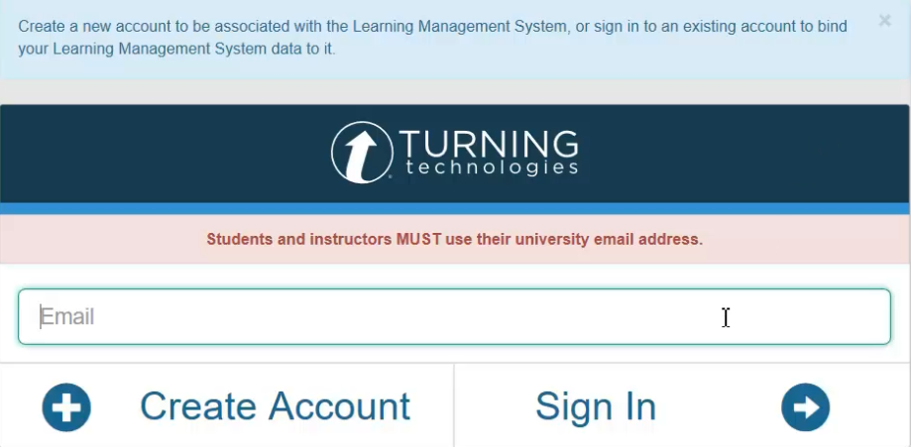
- After signing in, if a subscription was not purchased you are now able to do so.
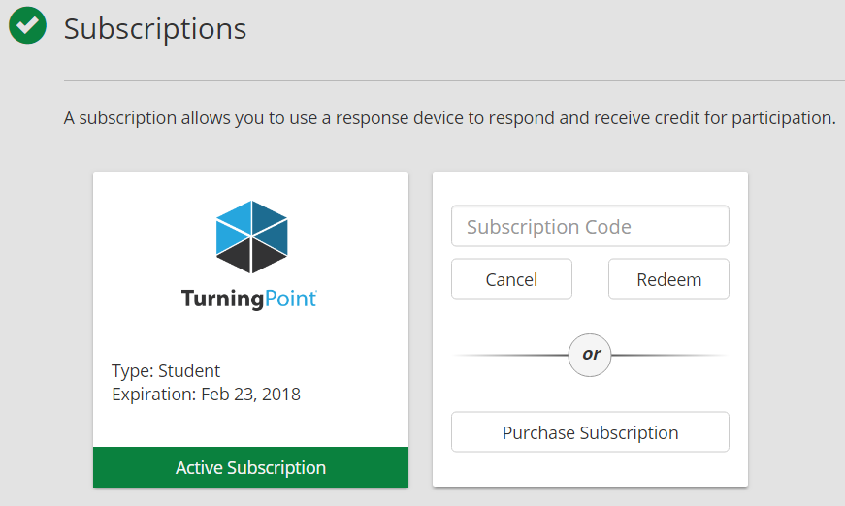
- Clicker devices can be added as well.
